Health Council Application Form

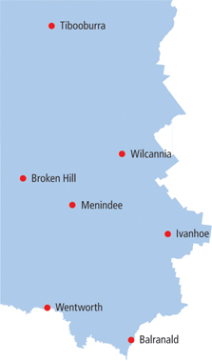

WILCANNIA HEALTH COUNCIL APPLICATION FORM
Title: Mr / Mrs / Ms / Miss /Other (please circle)
Family Name:
Given Name:
Address:
Town: |  |  |  | Postcode:
Tel: | (H) | (B) |  | (M)
Email:
Country of Birth(Optional):
Are you of Aboriginal or Torres Strait Islander descent? | □ No □Aboriginal  □ Yes □Torres Strait Islander  □Both
Date of Birth: |  |  | Gender: □ Male □ Female
National Criminal Record Check Form completed: □ Yes □ No
Signature: |  |  | Date:
Office use only:
National Criminal Record Check Form completed: □ |  |  |  |  | 100 Point Identification Check: □
Recommended by:
Health Servicer Manager: |  |  |  |  | Date:
Chair Health Council: |  |  |  |  | Date:

Why are you interested in becoming a Health Councillor?

We would like people on the Health Council to bring ideas from, and take information to their community.
Are you a member of? (Please list names of groups)
Informal interest groups eg mother groups?

Community ie support groups?

Sporting/ Recreation clubs?

Service clubs ie Lions, Rotary?

Local professional organisations?

What is your area of interest? Please tick all that apply
□Mother and baby health □Children
□Kidney services □ Mental health
□Heart and lung health □Preventative health
□Emergency services □Food services
□ Older people/aged care □People with a disability
□Carers □ Pastoral care services
□ Migrants / refugees □Governance / administration
□Quality and safety □Drug health
□Aboriginal & Torres Strait Islander people
□Other If Other, please describe:
What skills can you bring to the Health Council?

Referees
Name |  | Address |  |  | Telephone
6. Applicant’s statement
I understand and agree that all statements in this application are correct to my knowledge.
Signature |  |  | Date



