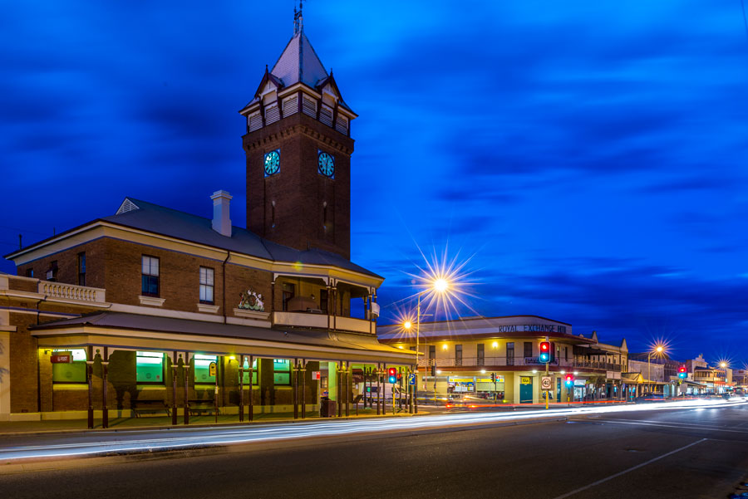

Broken Hill Health Council Action Plan

2020-2022

Our Vision
Excellence in Rural and
Remote Healthcare

November 9 2020

Far West LHD
Authored by: Manager Community Engagement Darriea Turley AM

Table of Contents
Acknowledgment of Country 4
Our Values 4
Far West Local Health District 5
Our Community 7
Our Plan 9
Reference and Data Sources 9

Acknowledgment of Country
The Far West LHD acknowledges the traditional owners of the lands within its boundaries including: the Barkandji; the Muthi Muthi; the Wilyakali; the Ngiyampaa; the Wadigali; the Malyangaba; and the Wangkumara. We acknowledge and pay respects to the Elders past and present and their ancient wisdoms. We also acknowledge the communities of today and the Aboriginal community members who are part of our communities.

Our Values

- Collaboration
- Openness
- Respect
- Empowerment

Our Health Council works with the Local Health District Board; Executive; Managers; and Staff to ensure the CORE values underpin all aspects of our activities.

Far West Local Health District

Demographic summary
The Far West Local Health District is located in the far west of NSW and provides healthcare services across a geographic area of approximately 194,949 square kilometres. The region has some of the most beautiful, though harsh, landscape in NSW and has been significantly impacted by the current drought.

The Barkandji; Wilyakali; Ngiyampaa; Muthi Muthi; Wadigali; Malyangaba; and Wangkumara are the traditional owners of the lands covered by the District. The region has three rivers - the Darling, the Murray and the Murrumbidgee. These rivers are significant for the traditional owners and provide connection to their lands.

The northern cluster of the District includes the towns of Broken Hill, Tibooburra, Wilcannia, Menindee, White Cliffs and Ivanhoe, which all have links with the South Australian health service, especially for flows to higher level health services. The southern cluster of the District includes the towns of Wentworth, Dareton, Buronga, Gol Gol, Euston and Balranald and links to Victoria for higher level health services.

The 2020 estimated residential population* of the District was 30,144. People of Aboriginal heritage make up 3,866 or 13 per cent of the population, compared to 265,865* for all NSW. The District’s representation of culturally and linguistically diverse communities is small, with 91.1 per cent of residents coming from an English-speaking background.

By 2036, the District’s population is expected to decrease by 9.6 per cent. However, a planned land release in the Wentworth Local Government Area may increase the population over the next 25 years. Mining and alternative electricity generation technology activity is also increasing across the District.

The proportion of the District aged 65 years and over is projected to increase from 18 per cent in 2016, to 29 per cent by 2036. It is expected that this growth will increase the demand for services in the District. Aboriginal community birth rates are also increasing. The District is responding by providing culturally safe and responsive healthcare, complemented by working with Aboriginal health service partners.

The demand for health services in the region has been changing in line with the ageing population’s increased rates of chronic disease. More recently, the impact of the drought on the wellbeing of far west communities has seen a need to enhance mental health and drug and alcohol services. We have seen the importance of this particularly for Aboriginal communities, with the lack of water in the rivers impacting their wellbeing.

In 2018-19, the rate of admissions for circulatory disease in the region was slightly lower than that of the rest of NSW. In 2018-19, the hospitalisation rates for chronic obstructive pulmonary disease and diabetes-related conditions were respectively two and three times the NSW rate. In 2018-19, the hospitalisation rates for intentional self-harm was twice the rate of all the local health districts. In 2019, an estimated 13.8 per cent of respondents in the region reported high or very high psychological distress, compared to 17.7 per cent across NSW.*

The District is keen to ensure the co-design of services based on community need. By enhancing models of care that focus on integrated care, patient centred value based care, telehealth and alternative treatment settings the District aims to reduce the use of hospital services and place a greater emphasis on the provision of primary healthcare and support for self-management.

*Source: NSW HealthStats

Our Community
The Far West LHD has four Local Government Areas (LGAs): Balranald, Broken Hill, Central Darling, and Wentworth as well as the Unincorporated Far West NSW (excluding Lord Howe Island).

Broken Hill
Population |  |  | Industry 2018/2019 | $M | Jobs
2019 | 17,479 |  | Mining, Construction & Manufacturing | 344 | 1,582
2014 | 18,627 |  | Household Services* | 226 | 1,811
2009 | 19,267 |  | Tourism** | 124 | 480
 |  |  | Retail Trades | 50 | 936
 |  |  | Public Administration and Safety | 61 | 600
Source: Broken Hill, A Blueprint Advocating for Our Future, Broken Hill City Council, 2020
Employment increased by 456 between 2013/14 and 2018/19. 50.3% (all industries) of workers were male and 49.6% female. In the 2019 September quarter, the unemployment rate was 3.9%. Mining was the most productive industry, generating $267 million in 2018/19.
*Household Services refers to Accommodation and Food Services, Education and Training, Health Care and Social Assistance, Arts and Recreation Services and Other Services. In 2019, the Household services sector accounted for 41.4% of employment. The importance of this sector has increased over the last 10 years (38.0% in 2009).
**In 2018/19, the total tourism and hospitality sales in Broken Hill City was $82.2m, the total value added was $41.6 million.

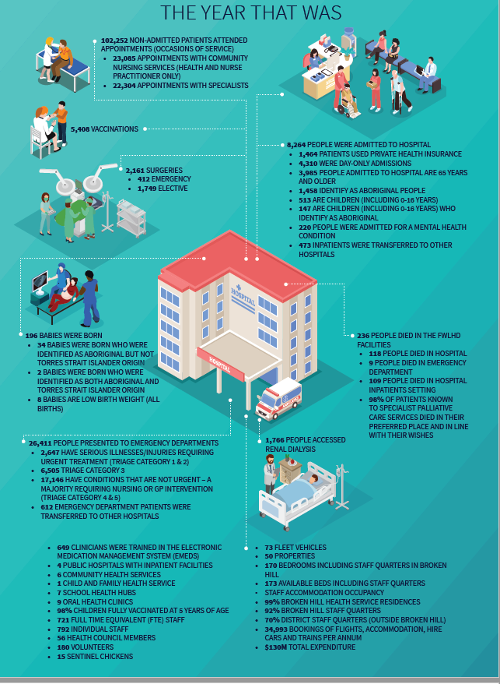
FAR WEST LOCAL HEALTH DISTRICT 18¦19 YEAR IN REVIEW

Our Plan
The issues and goals were developed by the Broken Hill Health Councillors in collaboration with the Director of Nursing and Midwifery and Site Manager.
Issue | Goal | Action | By Whom | When | Progress
Enhancing our communities' access to evidence based, high quality, integrated health care
Radiology services and access to MRI Cat scans and Ultrasounds | Reduce the impact on Broken Hill residents accessing MRI’s | Collaborate with partners to support any new body acquiring an MRI, include letters of support. | TBC | December 2020
Pets as Therapy program | Improve patient’s wellbeing. | Staff to draft Pets as Therapy policy | TBC | November 2020
Maintaining ethical standards to meet the responsibilities of all cases that are presented & undertaken at the Far West Area Health Centre and reporting that treatment of all patients is consistent across the board regardless of sex, religion, age, creed or ethnicity. | Improve patient experience |  | TBC | September 2022
Alternative services | Increase information regarding alternative therapies provided by Far West LHD | Update on alternative therapies provided within the Health Service. | Manager and Director Nursing Midwifery and Site Manager | November 2021
Delays for treatment and care | Improve access to treatment and care | Waiting time be tabled and discussed annually | Manager and Director Nursing Midwifery and Site Manager | November 2021
Communicating effectively with all stakeholders
To be more visible and relevant to the community | Monthly Profile of Health Councillors | Profile Template to be Circulated to Health Councillors. Profile and photos will be circulated to media and uploaded to Facebook | Community Engagement Manager and Director Nursing Midwifery and Site Manager | November 2022
 |  | Photo stock of Health Councillors | Community Engagement Manager and Director Nursing Midwifery and Site Manager
 |  | Health Councillors to attend Service Clubs and | Health Councillors to organise roster and negotiate with Service Clubs
Communication and consultation is open, honest & transparent from the CEO down the chain & back up the chain | Communication and consultation improves lead by the CEO | Annual meeting with the CEO | Community Engagement Manager and Director Nursing Midwifery and Site Manager | June 2022
Establishing the LHD as an employer of choice
Transfer/discharge of patients | Improve the patient experience on discharge and/or transfers to other health facilities | Discharge planner to present to the Broken Hill Health Council | Broken Hill Health Council | February 2022
 |  | Health Council to request Board to report on progress to address patient experience for patient transfers and discharge to other health facilities.
Personal safety & care of all hospital employees, clients, staff, Doctors, Nurses, Specialists & public visitors & patients whether inpatients or outpatients. | Ensure personal safety & care of all hospital employees, clients, staff, Doctors, Nurses, Specialists & public visitors & patients is a priority npatients or outpatients. | Annual meeting with the Security Manager | Manager and Director Nursing Midwifery and Site Manager | 2022 June 2020
Maintaining accountability for all resources available to the LHD
Parking for staff and Patients | Improve parking for patients and ensure safety for staff | TBC | TBC | May 2021
- Maintaining ethical standards to meet the responsibilities of all cases that are presented & undertaken at the Far West Area Health Centre and reporting that treatment of all patients is consistent across the board regardless of sex, religion, age, creed or ethnicity. | Maintaining ethical standards to meet the responsibilities of all cases that are presented & undertaken at the Far West Area Health | Presentation on Clinical Governance Unit on ImmsPlus | Manager and Director Nursing Midwifery and Site Manager | September 2021
Collaborating effectively with all stakeholders who can help us to enhance the health of our communities
Regular Specialist visits from Adelaide | Improve access to specialist services in Broken Hill | Specialist Clinic NUM to present to Health Council | Director Nursing Midwifery and Site Manager | November 2020
Reduce waiting lists for elective surgery and other procedures | Improve waiting lists for elective surgery and other procedures | Report to be presented to Health Council on waiting lists for elective surgery and other procedures | Director Nursing Midwifery and Site Manager | June 2022
Health Councillors engaged in their roles | Improve Health Councillors Experience | Evaluated Health Councillors Satisfaction bi annually | Community Engagement Manager | September 2022

Reference and Data Sources
Australian Bureau of Statics
Far West Local Health District, 18¦19 Year In Review, 2019
Broken Hill, A Blueprint Advocating for Our Future, Broken Hill City Council, 2020
FW_PD2020_031 Consumer, Carer and Community Engagement, 2020
Far West Local Health District, Health Council Guidelines, 2020
NSW HealthStats, 2020

